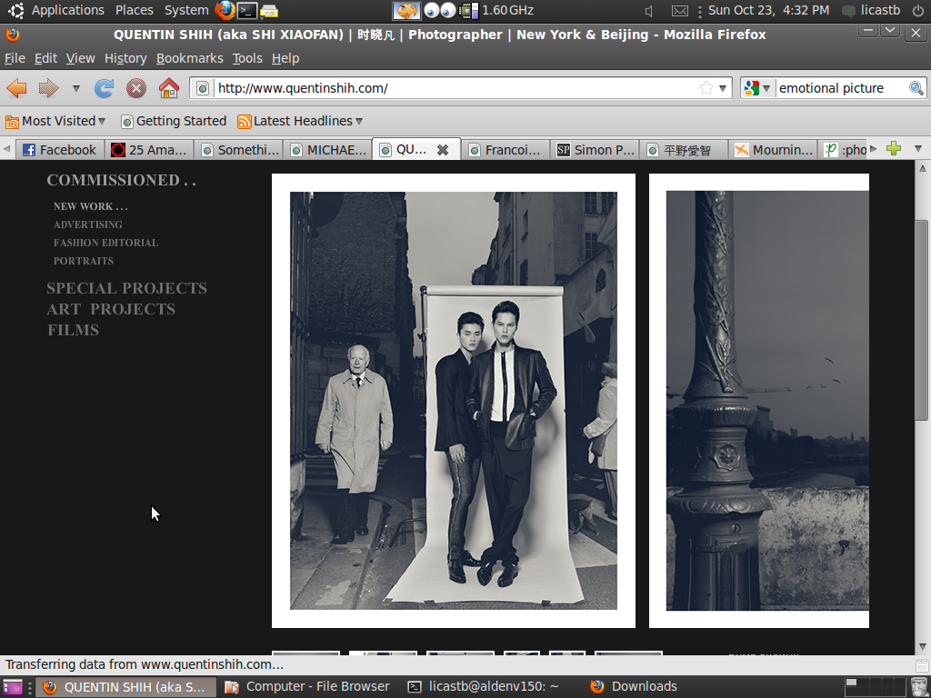

This photograph taken by Quentin Shih displays strong use of the rule of thirds. What really caught my eye was the use of two totally separate subjects in the piece. The person on the left is walking down the sidewalk as he would on a typical day (or it appears this way) while the two men on the right have clearly been staged. This makes for a very unique photograph which leaves its viewer wondering what the message is, and what the person walking by is thinking.